Concept Paper:



Including:

● “Lunar COTS”
● Reusable Cis-lunar vehicle / lander (OTLV)
● The first, cis-lunar infrastructure mission
● Telerobotic harvesting of lunar polar ice
● L1 and Cis-lunar Circuit missions
● Preparation for manned lunar return
● Manned maintenance and expansion of the telerobotic
workforce
● Progressive capabilities

See also:

CisLunarOne.com

LunarCOTS.com
Glossary of Terms

BEO Beyond Earth orbit
CCDev Commercial Crew Development
CCiCap Commercial Crew integrated Capability
COTS Commercial Orbital Transportation Service
CRS Commercial Resupply Service
DOD The Department of Defense
FAR Federal Acquisition Regulations
GEO Geosynchronous orbit
LCOTS Lunar Commercial Orbital Transportation Service
LCROSS Lunar Crater Observation and Sensing Satellite
LEO Low Earth orbit
LH/LOX Liquid hydrogen and liquid oxygen
LLO Low Lunar Orbit
LPS Lunar Positioning System
NASA The National Aeronautical and Space Administration
OTLV Orbital Transfer & Landing Vehicle
RTG Radioisotopic Thermoelectric Generator
SLS Space Launch System
TLI Trans-lunar Injection
ULA United Launch Alliance
Cis-lunar One: A Sustainable Plan for Opening the Solar System

Overview
This document describes a proposed architecture for the establishment of cis-lunar infrastructure based upon the exploitation of ice in the permanently shadowed craters at the lunar poles. This infrastructure could deliver inexpensive fuel based upon lunar ice to depots on the Moon and at L1 and LEO. Such fuel would benefit multiple customers including NASA, the DOD, as well as GEO satellite, tourism, and space solar power companies.

SECTION 1 – ONE-LAUNCH, CIS-LUNAR INFRASTRUCTURE

Lunar COTS Funding

It is proposed that the development of a cis-lunar transportation infrastructure be funded by means of a NASA public-private partnership very much like the current such programs. The current COTS, CRS, CCDev, and CCICap programs are widely recognized as being one of the most successful of NASA programs. A NASA study in 2012 found that the development of the Falcon 9 cost NASA only about a third of what it would have cost if the traditional FAR approach had been used. These public-private approaches require that the private companies invest some of their own money, NASA oversight is reduced, and payments are made only after the companies reach their milestones. Any cost overruns are eaten by the companies so that NASA's stays on budget. Just like the goal of the current commercial programs is for the companies to get to the point where the markets are sharing the burden for the new commercial services, likewise, with the Lunar COTS program, the goal would be for the companies to provide in-space propellant to not only NASA but to other entities in the market. In this way, NASA could help American commercial companies to extend America's commercial space to include the resources of the Moon.

The Lunar COTS program would be composed of four parts:
- Commercial Cis-lunar Transportation Service
- Commercial Lunar Surface Operations
- Commercial Cis-lunar Supply Service (lunar and orbital)
- Commercial Lunar Crew
Parts 1, 3, and 4 each have their parallels in the current commercial programs. Only Commercial Lunar Surface Operations would be a new approach.

In the Commercial Cis-lunar Supply Service, it is proposed that NASA would serve as the anchor tenant guaranteeing the purchase of a set amount of propellant at a fixed price. It is suggested that NASA could agree to the purchase of not only its current BEO propellant needs but perhaps ten years' worth of their propellant needs. This would provide the financial base and time from which the participating companies could begin to develop new markets given low-cost LEO propellant.

A Lunar COTS petition has been set up at LunarCOTS.com to encourage NASA to follow-up its current commercial programs with the Lunar COTS programs. Signers of the petition include those from NASA, industry, advocacy, academic, and media backgrounds.

Should Lunar COTS funding not be made available, it is none-the-less calculated that revenue from just the first Cis-lunar One mission could pay for development costs and begin showing a profit. In brief, each 65 tonne delivery of propellant to LEO would be valued at about $5,000/kg totaling $325 million per delivery trip. In about two-and-a-half trips, the program would break even and start to return a profit.

Single Launch Cis-lunar Infrastructure
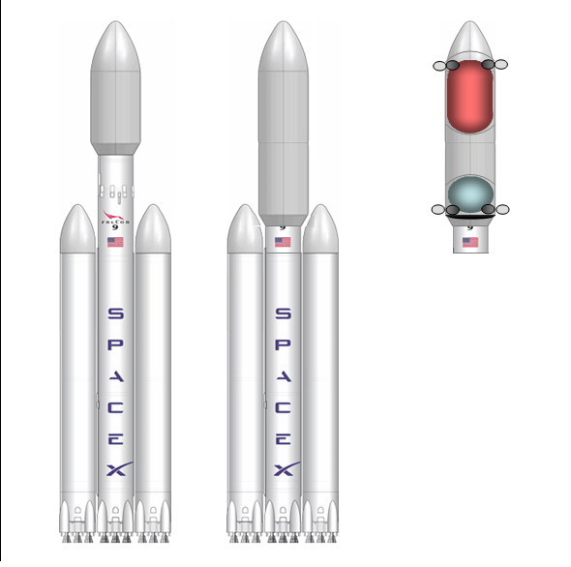
The plan assumes the availability of Falcon Heavy launches.
The necessary characterization of lunar ice before harvesting missions would commence would be conducted by other companies who are presently developing those capabilities. Astrobotics among others should be able to provide prospecting services before the time that the Cis-lunar One missions launch.

The concept envisions a single launch of a Falcon Heavy which would deliver about nine tones of hardware to the lunar surface for the initial extraction and processing of lunar ice in order for the initial return of lunar water to LEO. This single mission would provide enough fuel to bootstrap operations from then on. In this way, only a single launch is necessary in order to deliver profitable amounts of lunar ice-derived water to LEO.

Orbital Transfer and Landing Vehicle (OTLV)
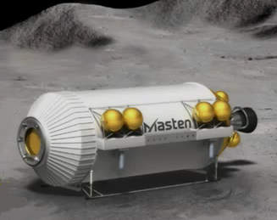
ULA is working with Masten Aerospace in developing a similar concept of a cryogenic lunar lander.
At the heart of this architecture is a reusable orbital transfer vehicle which also serves as a lunar lander. This would mass about 5.8 tonnes dry, 34 tonnes fuelled, and about 99 tonnes fully fuelled and loaded with water payload. It would be launched on top of a Falcon Heavy, use four throttleable hydrolox engines, be largely cylindrical in design, with a frontal heat shield, rear heat shield flaps, and four extendable legs. It would land on the lunar surface belly down.
The OTLV would serve as a reusable "space truck" constantly ferrying water from mining operations at a lunar pole to destinations at L1 and LEO. It would designed and constructed anticipating that it would eventually be man-rated in order to transport humans to oversee the maintenance of telerobotic mining equipment.

The Initial Mission
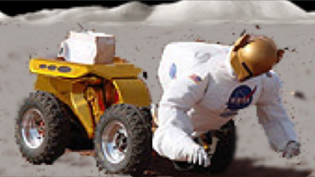
Even with a 3 second delay, we ought to be able to conduct teleoperated repairs especially if equipment was designed for that. Robonauts should be able to swap spare parts on other Robonauts. Credit: NASA.
The Initial Mission would use a partial Falcon Heavy rocket with the OTLV on top of the central stage. The lateral boosters would be standard. Upon achieving a parking orbit, the OTLV would accelerate into a TLI trajectory and enter into a stable low lunar polar orbit at 86 degrees. At that point a half-dozen small satellites would be released for communication links and an LPS system.

The initial target would be a permanently shadowed crater on the north pole near a “peak of eternal light”. After landing, the OTLV would immediately discharge a small, dexterous teleoperated rover which would head to a peak of eternal light where it would establish an array of solar panels to power operations. Several different methods of power transmission to the OTLV in the permanently shadowed crater are discussed (see Appendix 3).

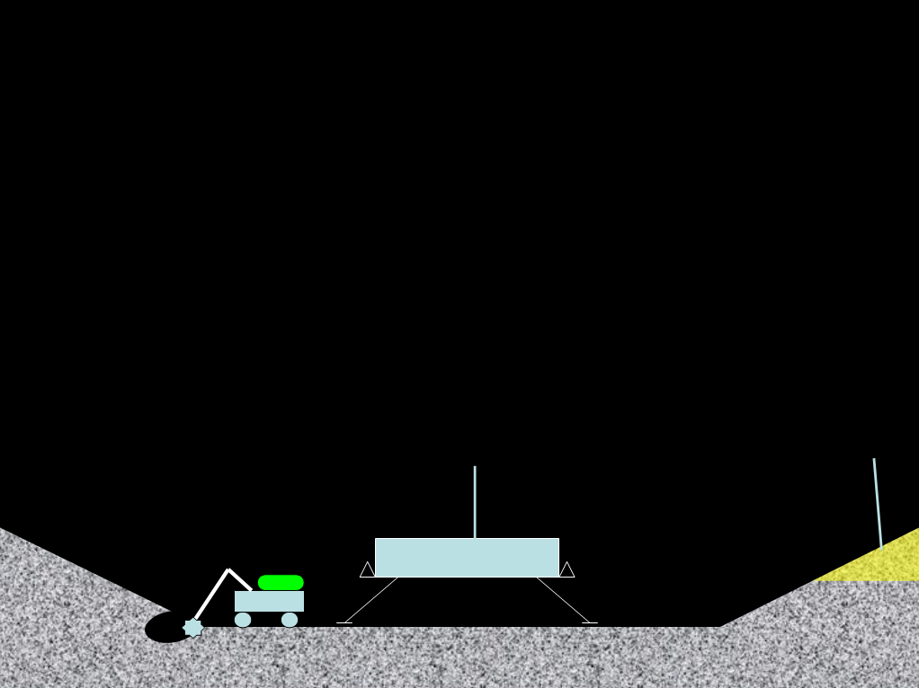
Later, a decent-sized excavator and processing equipment would be discharged from the OTLV. The excavator would immediately search and begin the excavation of the icy regolith. It would then bring it back to the processing equipment where volatiles would be steamed from the regolith. Dry regolith would be discarded to the side and the condensate would then be distilled and fractionated. All fractions would be stored for later use. The LCROSS mission demonstrated that volatiles make up about 15% of the icy regolith in the permanently shadowed crater near a lunar pole. The two largest components of the ice are CO (5.7%) and H2O (5.6%) (http://clowder.net/hop/TMI/LunaGraphics.html). This opens the possibility of methane for fuel due to its far higher boiling point than hydrogen’s and therefore greater ease of handling and transferring (Methane = 109 K; Hydrogen = 20 K).
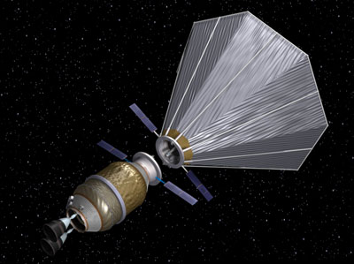
Orbital depots would include water bladders, hydrogen (or methane), and liquid oxygen tanks, and solar panels in order to prevent boil-off. There is also a sun shade. Propellant would not be produced constantly but only in preparation for sale when it is needed. Credit: ULA.

Cis-lunar Routes
There would be three routes of the cis-lunar infrastructure:
- The Initial Launch – This would be a one-way trip of an OTLV filled with fuel and equipment from LEO to LLO. This will deliver about 9 tonnes of equipment to the lunar surface.
- The L1 Circuit – From the lunar surface to the L1 depot and back in order to provide the water and fuel needed to complete the Cis-lunar Circuit. This will deliver about 21 tonnes of water to the L1 depot.
- The Cis-Lunar Circuit – Starting from the lunar surface, a fully fueled OTLV travels to the L1 fuel depot, and loads its water payload and some fuel. It then departs for Earth, performs aerobraking, circularizes into LEO, and delivers as much as 65 tonnes of water to the LEO depot.
Initially, there are options for interim missions which demonstrate aspects of complete circuits without requiring all of the fuel nor full aerobraking.

Additionally there are two manned missions. In the Manned Landing Mission, astronauts are taken from Earth's surface to LEO using a man-rated launcher. They would then dock and transfer into an OTLV which would proceed to deliver them to the lunar surface. For a Manned Return Mission, astronauts could take an OTLV from the lunar surface to either LEO for transfer to a capsule or even conceivably directly to Earth's surface in an extreme emergency losing part or all of an OTLV in the process.

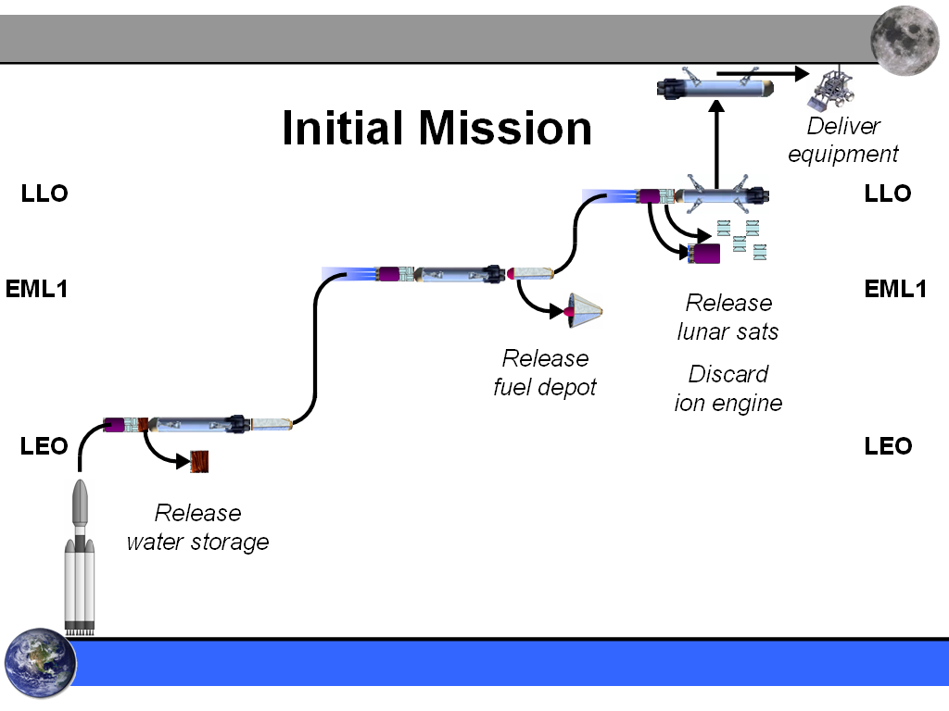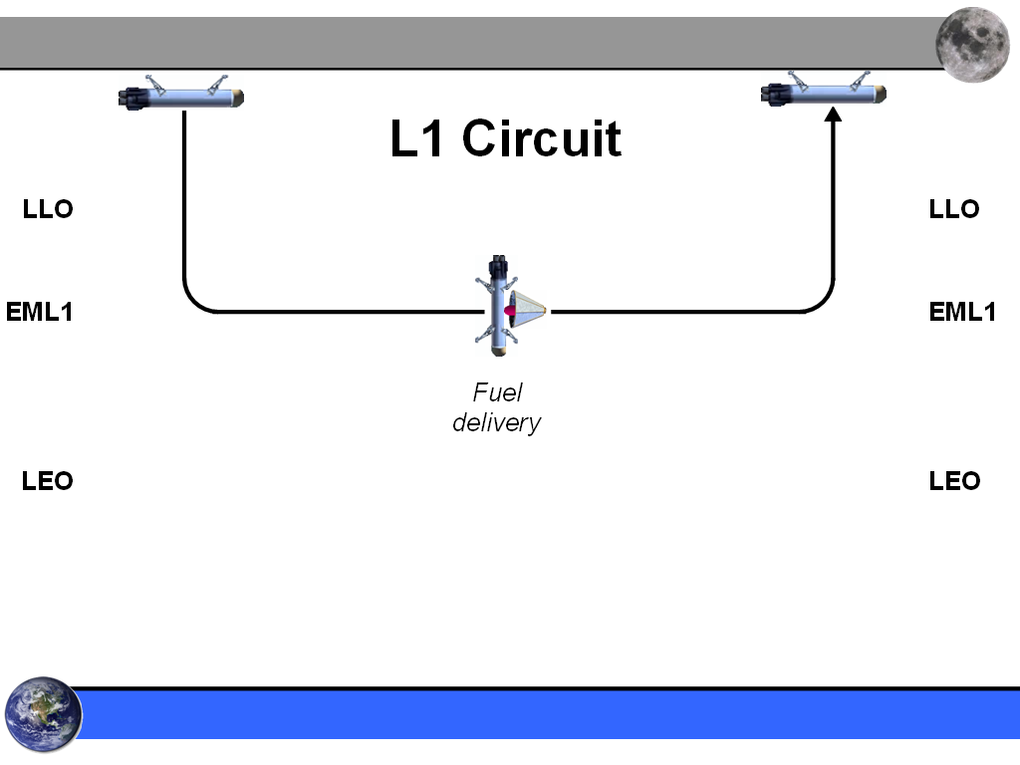

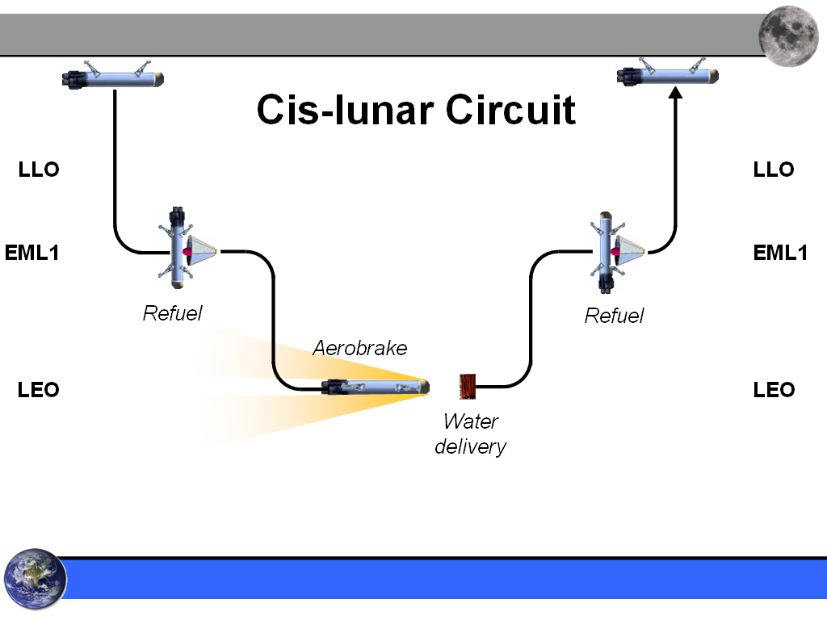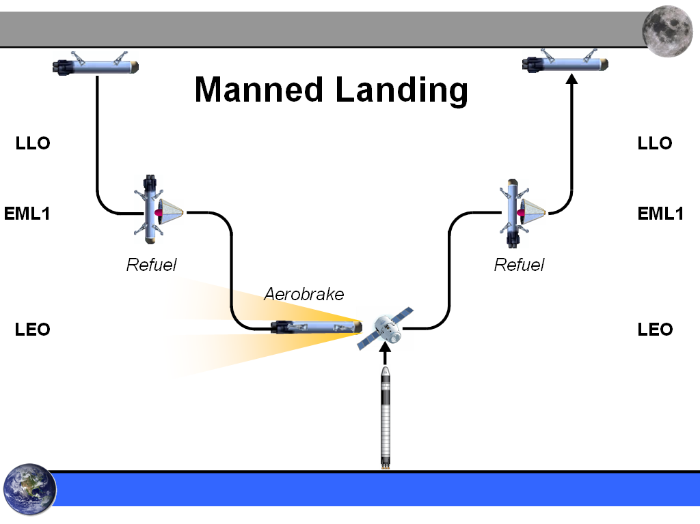

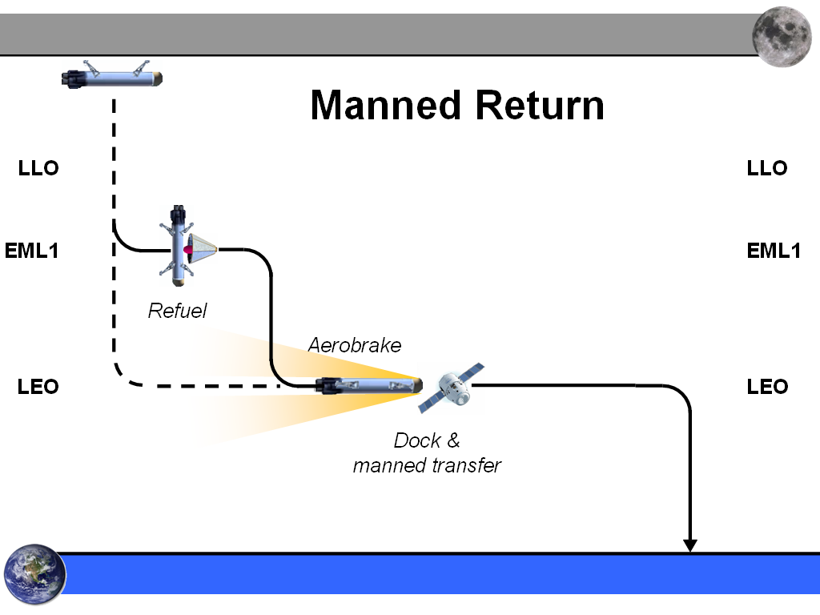
Future Operations

The OTLV would be able to make several Cis-lunar circuits before its cryogenic engines needed replacement. Eventually, several OTLVs would be needed at any given time in order to continuously provide water for fuel and provide continuity of operations should one OTLV fail.

SECTION 2 – PREPARATION FOR MANNED RETURN
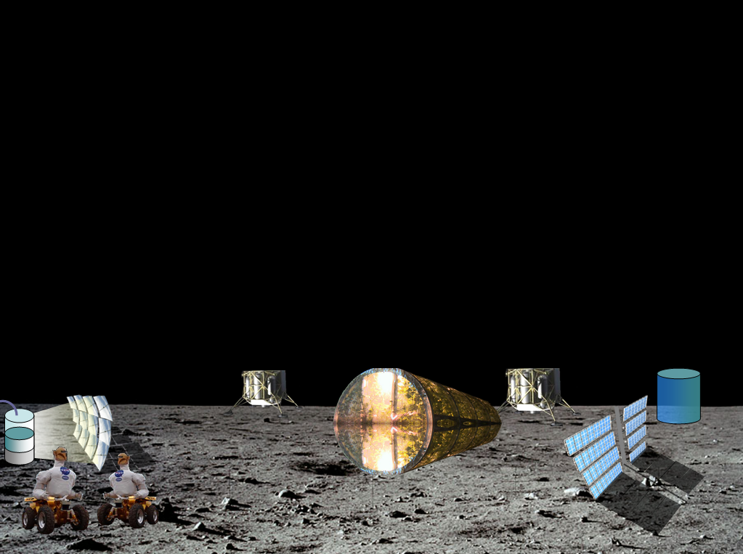

In the process of developing lunar surface infrastructure, hardware, and operations, it would make possible the establishment of a permanently manned lunar base. The electrolysis of water ice would provide breathable oxygen. Lunar ice CO and NH3 would provide the carbon and nitrogen necessary for the growth of plants. Plants would be grown underground in a lunar greenhouse such as the one that the University of Arizona is developing (http://www.space.com/9353-lunar-greenhouse-grow-food-future-moon-colonies.html).

Excavators could dig into a lunar hillside creating a regolith-covered cave. Dexterous robots could place supports and inflate an air-proof liner within it which would have an airlock. In this way, air, water, food, and a shielded habitat would be ready before humans arrive.

Human Rating the OTLV
As the cis-lunar infrastructure comes into operation, the safety of the OTLVs will be better understood. If the design proves reliable then individual OTLVs will have successfully completed the Cis-lunar Circuit. The probability of a successful next circuit would be good. All OTLVs will be designed according to known human rating standards as SpaceX did with its launcher and capsule. Astronauts would be launched to LEO using regular capsules. They would then transfer from their capsule to the OTLV which would then take them to the lunar surface using the automated landing methods that it had used to deliver cargo.

The Role of Humans
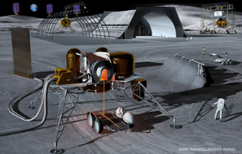
An illustration of ISRU metal production.
Used with permission: Skycorp.
The initial goal of the astronauts would be to secure their own life-support production and habitat. However, their occupation would be to repair the teleoperated equipment, produce bulky metal parts from processed iron in the regolith, and assemble new telerobots using these parts and high-tech equipment transported in cargo deliveries. This would result in an ever-expanding army of telerobots which would be operated by shift-workers on Earth. In this way, economic self-sufficiency of the program would be sought thereby relieving NASA to begin looking beyond the Earth-Moon system.

Private Settlers
It is proposed that the first humans back to the Moon be private. Although the systems described would be reasonably safe, early settlement is of such importance to humanity that the program cannot afford to be developed slowly or undergo years-long suspension and investigations should an accident occur. Whereas NASA funding could play a major role in establishing the infrastructure including the human-rated OTLV, it would be clear that the risk for the first settlers would be their own to take.

SECTION 3 – EARLY SETTLEMENT

Order of Human Return

The OTLV’s would deliver two astronauts/settlers at a time. It is proposed that the first two be American males who are the husbands of later arriving female astronauts. The second set of astronauts would include the wife of one of the first astronauts and a third husband. The landing of the first woman on the Moon would likely be watched by billions of people. Her being united with her husband would be a poignant and memorable moment and would signal to all that the first steps to the permanent settlement of space was taking place. The third set of astronauts would be the wives of previous astronauts / settlers. Birth control would be entirely necessary until animal research indicated that having children on the Moon was safe. This may require the development of centrifugal gravity first.

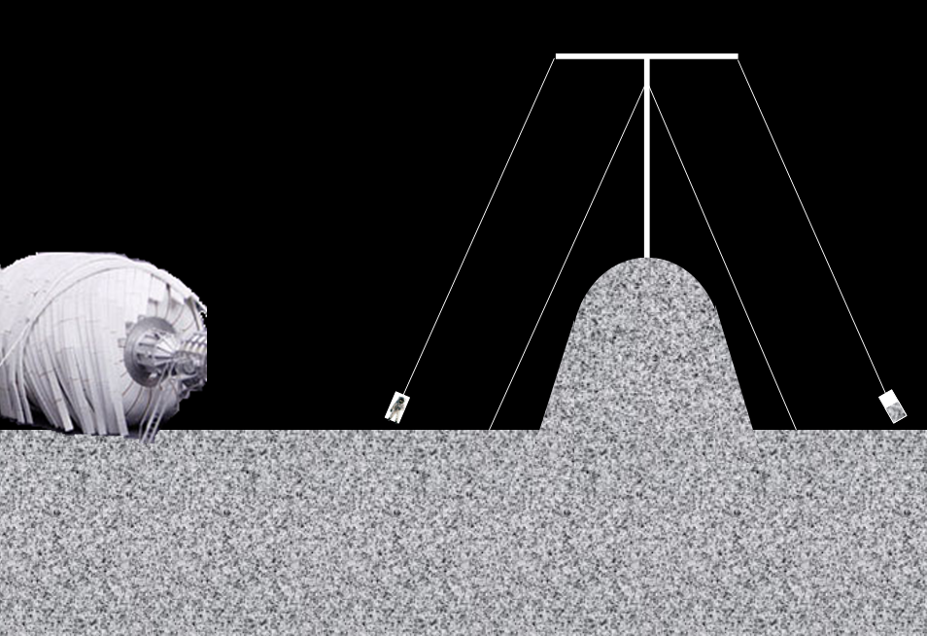
“Tetherball” centrifuge: A potentially early method for providing a total of about ½ g’s. Length of cable is about 33 meters.

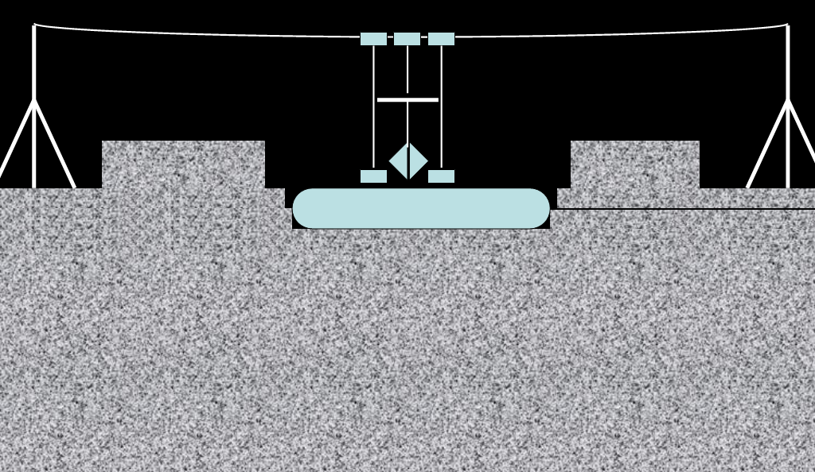
A cleaner, teleoperated method of digging and covering a place for a habitat using a pressure vessel from local metals.

Progressive Self-sufficiency
The astronauts on the Moon would only rarely come out of their sheltered habitat so they would have little radiation exposure. If they maintain a good exercise regimen, and maintain their life-support supplies, they ought to be able to stay on the Moon for years before needing to return.

The more the base could supply for itself, the fewer cargo deliveries would need to be sent and hence the lower the cost of the program. As described to this point, much of the daily consumables and bulky parts would already be produced and the living environment would be fairly safe. It should be noted that a single delivery of 20,000 kg of cargo could provide decade’s worth of computer chips, cameras, radio equipment, etc. So the base could become a “sufficient” colony meaning that it could have enough supplies on hand to operate independently of the Earth for a long enough period of time that the colonists would have time to eventually be able to build the capacity to provide for its own technologic needs. However, this would probably mean developing 1940’s-like technology and creative work-arounds. A large civilization is not necessary to provide the minimum needs of a lunar colony.
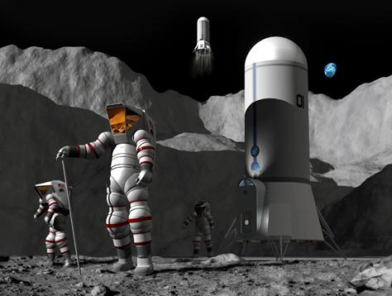
Space suits could be produced from local resources. Credit: NSS.

Ensuring a Human Population
It is evident that an off-Earth settlement is the natural next step for humanity while providing a valuable second home. Because even an early manned base could provide its own life-support, it would be prudent to attempt to achieve complete self-sufficiency from Earth. A biologic “back-up” of humans and the biosphere would start to come within reach. Human diversity could be preserved by establishing frozen stores of about 1,000 diverse human embryos be transported to the Moon and stored under regolith, in a permanently shadowed crater, near the colony.

BioPreserve
A Lunar BioPreserve would be the ultimate biologic store being more secure than any such preserve on Earth. So, it is proposed that a large consortium of regional universities throughout the world collect samples from a broad swath of the biosphere (except only a small fraction of insects such as the 30 million species of beetles). It is calculated that the known biosphere could have its cells or DNA stored in two payload deliveries in compartments measuring about 2 cubic millimeters. Another such BioPreserve should be transported to a Mars colony when it is developed.

Known Species
10,000 | Monera (bacteria)
65,000 | Protista (parasites)
75,000 | Fungi
300,000 | Plant
500,000 | Animals (minus insects)
375,000 | 1/40th of insects
1,325,000 | TOTAL

Establishing Another Biosphere
Much of the biologic world probably cannot be grown only from its frozen single-cell form. But to some extent the biologic world can be developed by inserting DNA into the eggs of related species. The resulting individuals could then be used to develop further related species. Unfortunately this may require establishing a living zoo of certain representative animals. This probably could not be accomplished until some years after the colony were established.

But in the final analysis, much later technology might be needed to develop species from DNA alone. There is the issue of the Minimum Viable Population (MVP) which means that hundreds or thousands of individuals of the same species might be needed in order to produce a genetically viable population. If this is the case then some decisions would need to be made about which are the most important species to preserve. These could be species including keystone, food, micronutrient producing, and those considered of value to humans.

Mars Settlement
If cosmic radiation during the trip to Mars is a show-stopper, the Moon could provide the approximately 500 tons of water shielding needed. By reason of routine cis-lunar water deliveries to the L1 depot, this shielding could be provided. Either hydrolox or ion propulsion could be used to push that shielding into an Aldrin Clycler orbit. In this way, settlers could travel to Mars every two years using the same shielded ship.

From Lunar COTS to an Independent Mars Colony
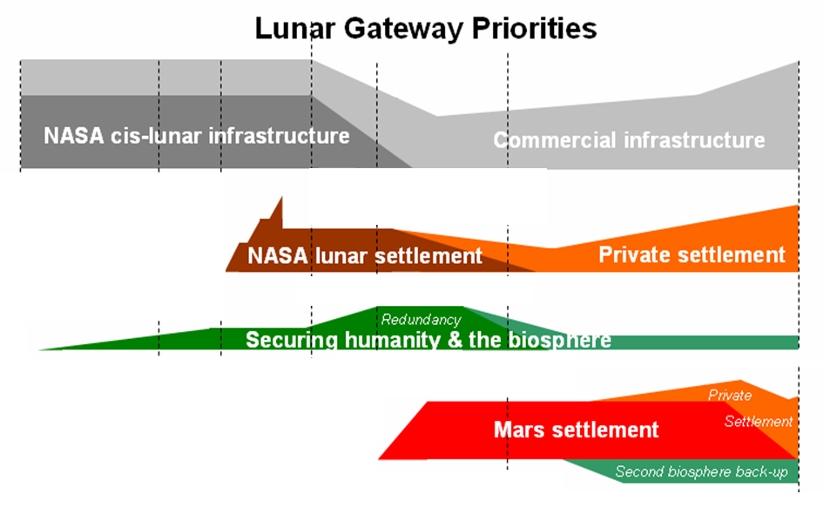
An imagined outline for the initial development of the Moon and Mars. Emphasis is given on establishing early self-sufficient colonies and backing up the biosphere. Total time would be about 40 years. This graph also represents a planned transition from government support to fully private and economically viable settlement.
SECTION 4 – APPENDIX
1. Program Timeline

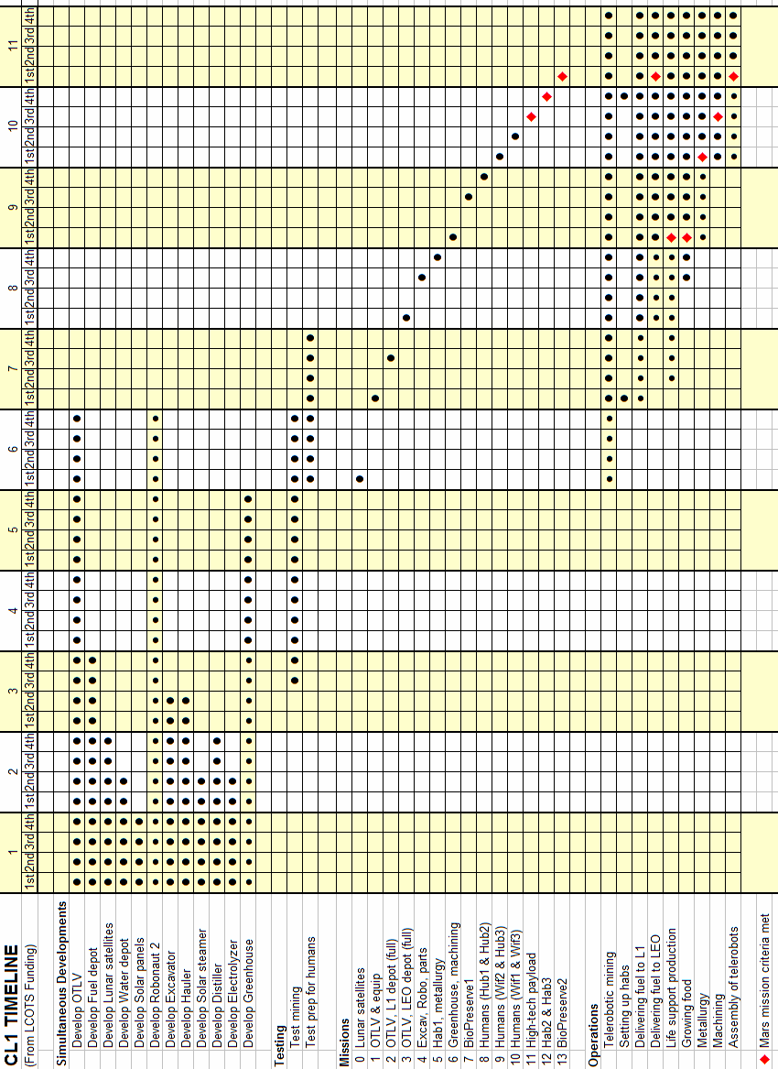

3. Power Transmission Options
Instead of having to constantly drive from the sunlit crest of a permanently shadowed crater to the icy regolith below, there are several options to get around this including:
- Radioisotopic thermoelectric generator (RTG)
- Laser (or maser) power transmission
- Wires (perhaps superconducting)
- Could be driven, or shot like a wire-guided missile
- Shooting or tossing processed ice to the crest for pick-up by a rover
- Mylar mirrors at the crest to solar panels in the shadowed crater
- Fuel cells could also provide a high-density, renewable, and transportable form of energy.

4. Sustainable Space Development “Firsts”
For those who feel the necessity for America’s space program to excite the public and inspire kids to STEM education, lunar return will provide no shortage of firsts:
- Robonaut 2 on the Moon
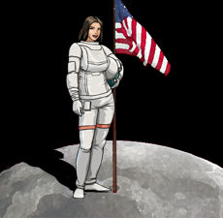
- The first permanent lunar habitat & green house
- This generation’s Moon Shot
- Record times spent in space

And the big one…
- The first woman on the Moon

But also…
- The first couple
- The first pet on the Moon
- Life support self-sufficiency
- Metals & glass produced Credit: Unknown
- The first telerobot assembled using some ISRU parts
- Centrifuge working

5. Lunar COTS Petition (LunarCOTS.com)

We, the undersigned, urge the establishment of NASA COTS-like programs for the commercial development of cis-lunar space including:
- cis-lunar transportation
- lunar surface equipment
- harvesting of lunar polar ice
- orbital propellant and servicing depots
- an initial crewed lunar base to support ice harvesting and processing operations

Specifically, we urge the establishment of the following programs:
- Commercial Cis-lunar Transportation Service
- Commercial Lunar Surface Operations
- Commercial Cis-lunar Supply (lunar & orbital)
- Commercial Lunar Crew

We believe that these programs will:
- serve the needs of NASA
- serve and expand commercial markets
- permanently and economically open up the solar system to human settlement

We believe that the recent cost-effective and ongoing success of NASA’s commercial programs have validated these public-private ventures and so gives good reason to extend this approach so that the Moon becomes included in our economic sphere.

Name: ______________________________________________________________________

E-mail: ______________________________________________________________________

About you and/or comments:_____________________________________________________

____________________________________________________________________________

____________________________________________________________________________

This information will be posted at LunarCOTS.com

